Step 1.Download and install VirtualBox on your machine:

<https://www.virtualbox.org/wiki/Downloads>

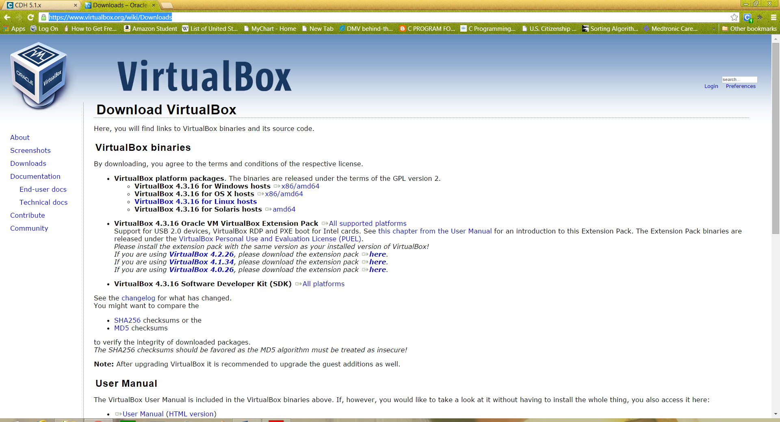

Step2 : Download the Cloudera Quickstart VM CDH 5 (Download for Virtual Box)

<http://www.cloudera.com/content/support/en/downloads/quickstart_vms/cdh-5-1-x1.html>

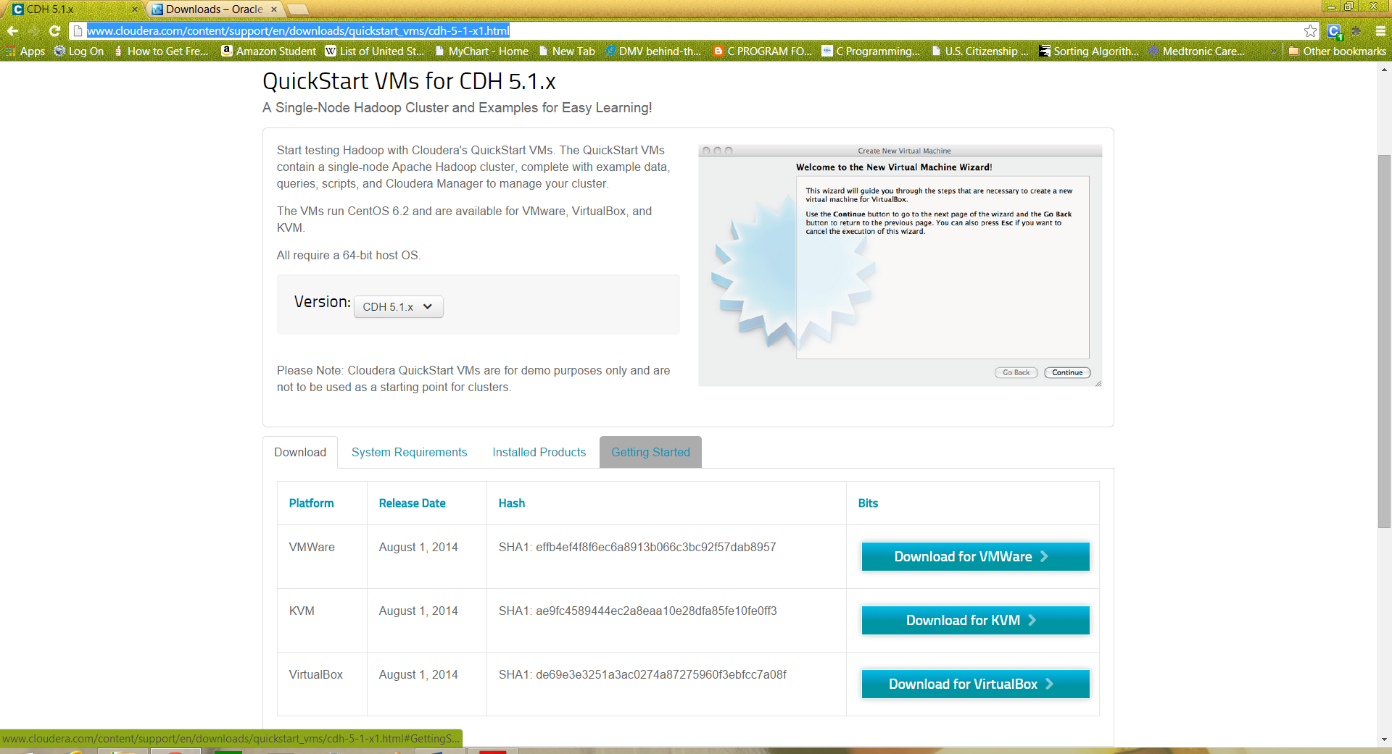

Step3: Install Virtual Box

Step4: Unzip the downloaded file (CDH5.X VM) and start Virtual Box

Start VirtualBox and click Import Appliance. Click the folder icon beside the location field.

Browse to the uncompressed archive folder, select the .ovf file, and click the Open button.

Click the Continue button. Click the Import button.

Virtual machine includes the following software

• CentOS 6.2

• JDK 6 (1.6.0 32)

• Hadoop 2.0.0

• Eclipse 4.2.6 (Juno)

The login user is cloudera, and the password for that account is cloudera.